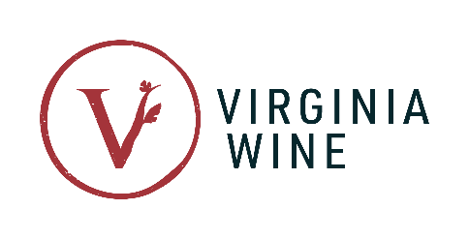
FOR IMMEDIATE RELEASE

Contact:
Virginia Wine Board Marketing Office, Annette Boyd
Phone: 804-344-8200
Email: information@virginiawine.org

Virginia Wineries Association Announces 2024 Virginia Governor’s Cup® Gold Medalists

Richmond, VA – The 2024 Virginia Governor’s Cup® Competition celebrates yet another historic year for the Virginia Wine industry. With an impressive 752 entries from across the state, 79 producers were honored with a total of 138 gold medals.

Now in its 42nd year, the competition has earned a reputation as one of the most rigorous in the nation, showcasing the finest wines, ciders, and meads produced in Virginia. The medals are the result of blind tastings conducted by a distinguished panel of judges. To earn a gold medal, a wine must achieve an average score of 90 points or higher on a 100-point scale.

This year, the judging process was led by competition director, Frank Morgan who brings an impressive 15-year history of writing about Virginia wines and over a decade of experience judging for the Virginia Governor’s Cup.

Morgan remarked, "As someone who has covered the Virginia wine industry for 15 years and judged this competition for many years, it’s an honor to now serve as the Director of Judging for the Virginia Governor’s Cup Wine Competition. This year’s record number of entries and top scoring wines showcase the continued growth in wine quality and diversity of grape varieties thriving in vineyards across the Commonwealth. I’m grateful for the support of the industry, competition volunteers and judges who contributed to making 2024 a record year for the Governor’s Cup."

The 2024 competition marks the most number of producers to receive gold-medals, reflective of the ever-growing quality found in wines and ciders across Virginia. Gold medals were awarded across seven regions, spanning seven vintages and twenty-six grape varieties, all grown in Virginia. Central Virginia wineries earned the highest number of gold medals, claiming an impressive 48% of the awards. Virginia red wines took the lead, winning over 55% of the total gold medals. Within this category, Red Blends rose to the top, securing 19% of total gold medals, making it the most awarded category, followed by Petit Verdot at 13%. White wines followed suit, earning a substantial portion at a little over 31%, with Virginia Chardonnay earning 14 gold medals. Varieties with growing popularity in Virginia like Petit Manseng, Albariño and Sauvignon Blanc were also awarded golds by the judges. The full list of gold medalists can be found at www.virginiawine.org/governors-cup/awards.

On March 7, the Virginia Wine Board will host the Virginia Governor's Cup® Gala at Richmond’s Main Street Station, revealing the top awards, including the Governor's Cup® Case, consisting of the 12 highest-scoring red and white wines, Best in Show Cider, and the coveted Governor's Cup®. For more information and ticket purchases, https://virginiawine.ticketspice.com/2024-virginia-governors-cup-gala

Virginia wine enthusiasts can sign up for the complimentary Gold Medal Wine Trail, a mobile passport featuring the 79 gold medal winners. As users check-in at participating venues, they unlock access to exclusive prizes and special offers. To pre-sign up for the Gold Medal Wine Trail or for more information, visit www.virginiawine.org/pages/taste.

For interviews and photo requests, please contact Annette Boyd at 802.344.8200 or annette.boyd@virginiawine.org.

About the Virginia Governor’s Cup® Competition

The Virginia Wineries Association’s Governor's Cup® is held in partnership with the Virginia Wine Board. All entries must be made from 100% Virginia-grown fruit to be eligible. Each wine is ranked based on a unified scoring system. For more information about the Virginia Governor’s Cup® Competition and for a full list of winners, visit: www.virginiawine.org/governors-cup.

###

