FOR IMMEDIATE RELEASE

CONTACT:
Virginia Wine Board Marketing Office
Annette Boyd, Director
Annette.boyd@virginiawine.org

Virginia Wine Contributes $1.73 Billion to Virginia Economy

Richmond, VA (June 30, 2022) – A new study finds the economic impact of Virginia wines to be an estimated $1.73 billion as of 2019. After evaluating all economic activity in Virginia related directly or indirectly to wine production, sales and wine grape farming, the study reports a 27% increase in overall economic impact from 2015 ($1.37 billion).

“We’re excited by the growing impact of Virginia wines and are proud to provide over 10,000 jobs and contribute almost $200 million dollars in taxes to the state,” said Kirk Wiles, Chairman of the Virginia Wine Board. “First and foremost, Virginia Wine is an industry of people— business owners, farmers, wine lovers— and we’re fortunate to be able to give back to the Commonwealth through the local economy.”

Almost all categories reported an increase from 2015; the number of full-time equivalent jobs (+27%), the number of wineries (+37%) and the revenue from wine-related tourism (+31%).

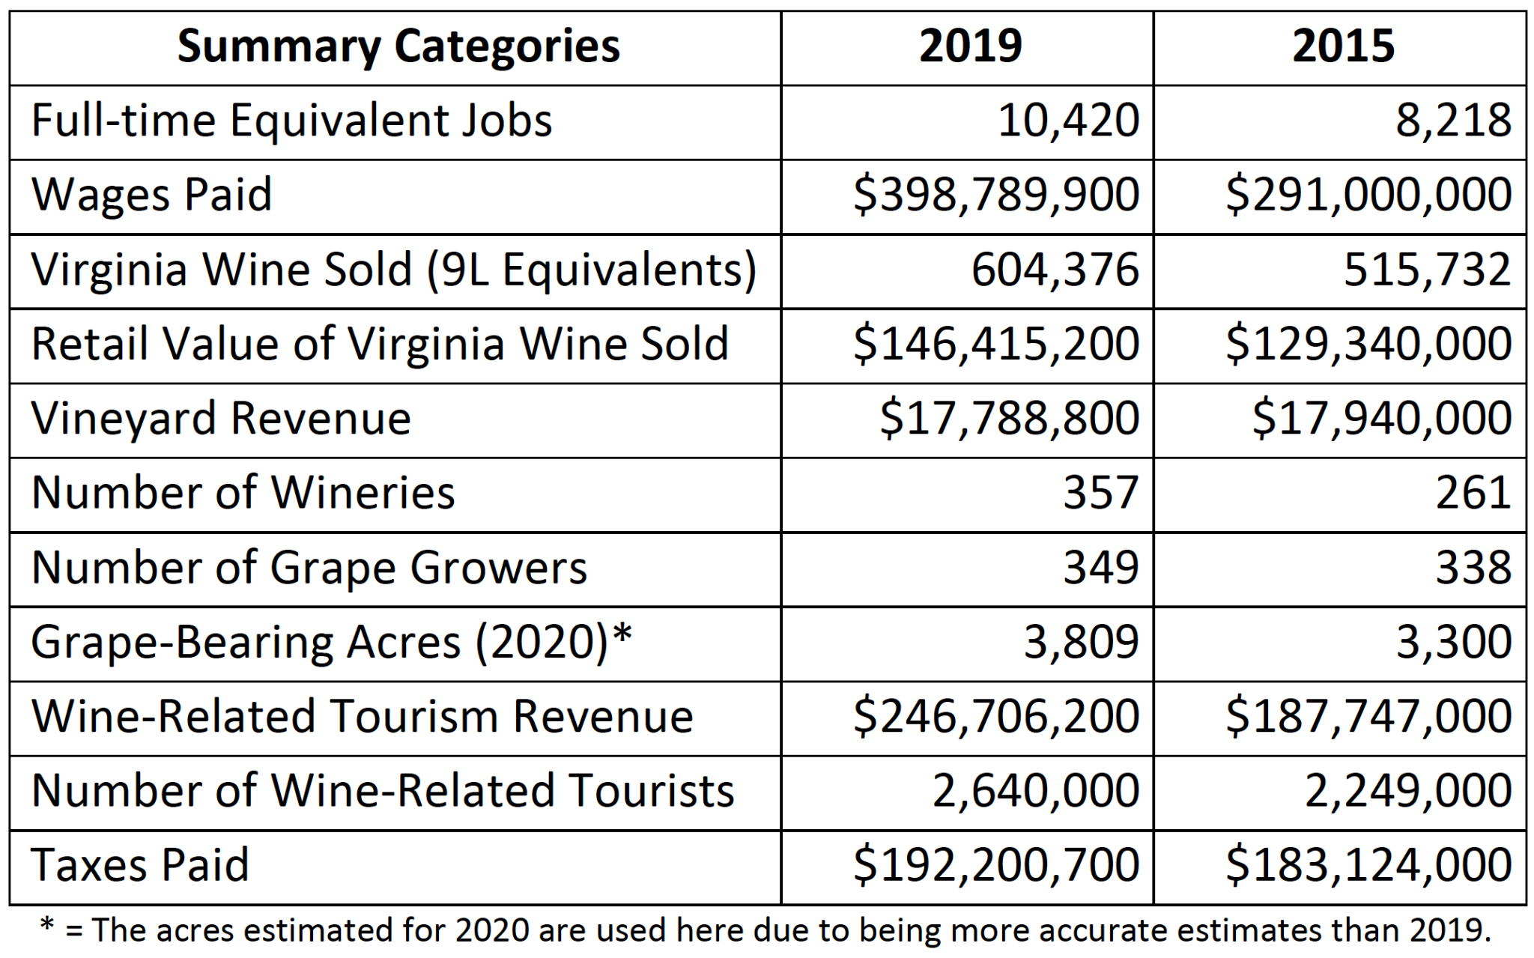

“The agriculture and tourism sectors are the biggest contributors to Virginia’s economy, thanks in large part to industries like Virginia Wine,” said Secretary of Agriculture and Forestry Matt Lohr. “I’m proud to represent and help support local, craft products as they remain a staple in the Commonwealth— and in this case, both for the quality of the wines and the evident impact to our economy.”

Economic Forensics and Analytics, Inc. conducted the analysis using IMPLAN® Modeling which uses input-output tables to aggregate and estimate economic impact for over 400 industries. For the full report, visit https://vaw-public-prod.s3.amazonaws.com/1d80df21e685a927e1647af1583c76a5.pdf.

For interviews and more information, please contact Annette Boyd at 802-402-1896 or annette.boyd@virginiawine.org.

###

